Query 1 - Students enrolled in "Physics 101"

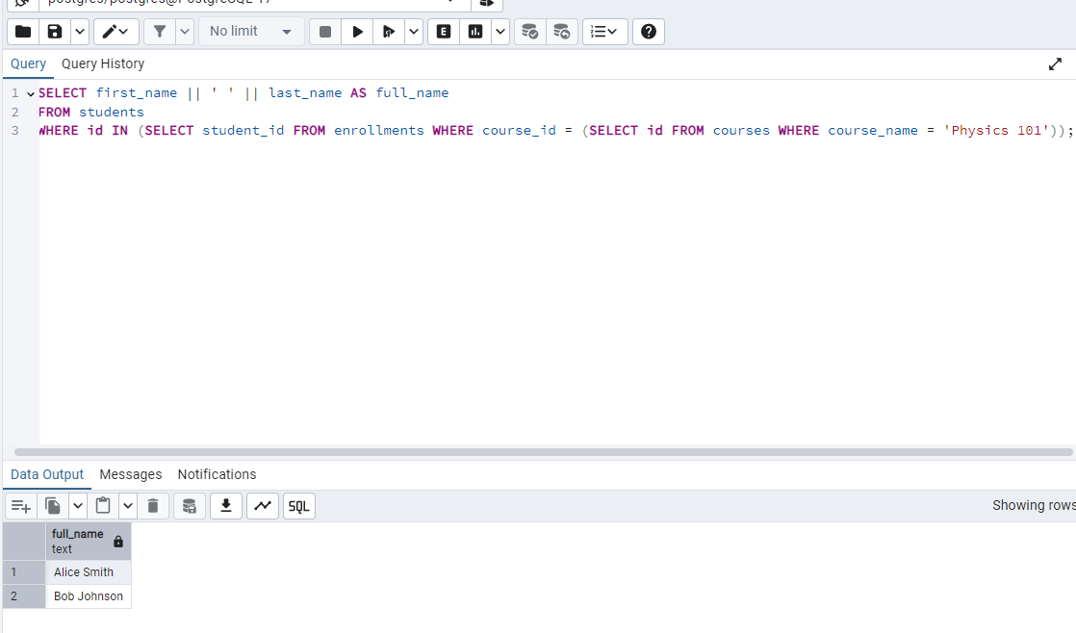

Query 2 - Courses and professor's full name:

Query 3 - Courses with enrolled students:

**Update Data**: Update one of the student’s emails.

**Delete Data**: Remove a student from one of their courses.

Table Students

Table Professors

Table Courses

Table Enrollments

